MLTAV Weebly Link: CLIL

1. 0. Measuring academic literacies progression not 'achievement'-based, but progression in Language - proficiency or standards-based? Is very current debate in Oz! How do we cross-reference measurement of progression, or do you see them as being tracked separately?

The issue of progression in CLIL is an interesting one which is evolving rapidly and will continue to evolve. First, I think we have to contextualize CLIL within education systems. We are at an interesting conceptual time globally in terms of pedagogic approaches to formal education. CLIL has to position itself within broad learning contexts which promote futures thinking and learning and it is clear that a narrow interpretation of integrating learning content and learning language is inappropriate. In fact, I believe the acronym to be somewhat misleading and would fully expect a new definition of CLIL to emerge during the year (ECML Graz Group)….. Reading the latest reports such as A Rich Seam – How New Pedagogies Find Deep Learning (Fullan and Langworthy, 2014), Hattie’s work and downloading numerous Ted Talks, all contain similar messages - that traditional education based on knowledge accumulation is no longer appropriate for many of our learners. Taking a quote from the Fullan Report:

- Many current curriculum standardized assessments that primarily measure content reproduction, are the greatest barriers to the widespread adoption of new pedagogies. Greater clarity and precisions of deep learning concepts, followed by valid new ways to measure deep learning outcomes, are essential for the expansion of the new pedagogies across whole systems. Deep learning outcomes are dependent on new learning partnerships between and amongst learners and teachers, tasks that re-structure learning and support knowledge construction and creation and it purposeful use, digital tools and resources that support and accelerate these processes.
- Connecting learning to students’ real lives and aspirations is often what makes the new pedagogies so engaging for many students. [2014:9]

The ‘new pedagogies’ can be defined succinctly as a new model of learning partnerships between and among students and teachers, aiming towards deep learning goals and enabled by pervasive digital access. (2014: 2)

Second, taking the point that current assessment procedures are there often to measure content reproduction, how we conceptualize learner progression and measure it appropriately is one of the greatest challenges for CLIL teachers. Often teachers question whether or not content knowledge should be assessed separately from language skills and raise the question as to what is more important – progression in conceptual understanding or developing appropriate language skills in terms of grammatical accuracy and the kinds of measure used on language tests across the world.
I do not believe we have yet solved this one because fundamentally separating out the language which learners are using as both a learning tool and an object of learning from the very meaning-making processing it is required to language is unfathomable – yet our assessment systems are not yet developed adequately to support such integration. If we can develop the kinds of tasks which demonstrate not only knowledge construction, but the languaging/articulation of which reflects appropriate genre, register and the like (SFL) then task outcomes enable learners to use their understanding through applying it in real world settings. Hence tracking progression in accordance with the syllabus for content knowledge and with a separate syllabus for language knowledge is neither helpful nor measuring learning.

Third, a more recent focus on literacies is bringing us a little closer to understanding what integrating conceptual and language progression might look like - both in L 1 and crucially with regards to CLIL in L2.

In the case of CLIL, ‘literacy’ also entails the capacity to describe and explain symbolic representations and forms (like, e.g. a curve diagram or a map) in a second or a foreign language, in the main language of instruction and/or in one’s native language. The latter elements of subject-specific literacies obviously also require meditational competences, or skills that allow learners to translate content matter from and between all the different language that are involved in literacy learning in a content subject. (Hallet 2012: 196)

Current research into learning processes and outcomes in CLIL classrooms are raising challenging questions with regard to the level of academic skills associated with learner progression of subject disciplines and their discourses in the secondary age range. CLIL provides potentially rich opportunities for building an individual’s meaning-making potential by integrating language and learning which requires learners to ‘language’ cognitive operations triggered by subject-specific tasks and then apply these. However, in school contexts progression along the knowledge pathway towards deeper subject understanding, calls upon a greater command of subject-specific literacies.

The Graz Group’s emergent Theoretical Model
The Graz Group is currently working on a theoretical model of literacies built on the premise that progression in subject understanding must be accompanied by progression in learners’ disciplinary or subject-specific literacies rather than in language skills per se. Thus far, little attention has been paid to ways in which a systematic and transparent approach to developing subject-specific literacies through an additional language and across different subjects can be practically applied in CLIL classroom settings. A conceptual map which charts the progression of literacies development across languages – hence the term pluriliteracies - and exemplified with classroom data of how this might happen in practice, is currently evolving. In this model pluriliteracies development involves the growing ability of individual learners to verbalise and express subject-specific concepts and knowledge in an appropriate style using appropriate genre moves for the specific purpose of communication in a range of modes. Thus, the study is exploring ways of strengthening the connections between the conceptual continuum and communication continuum which will enable teachers and learners across a range of contexts to progress classroom learning in CLIL. In embracing the demands of appropriate 21st century learning, this research suggests that a pluriliteracies-based approach to integrated learning will move practice forwards by focussing on ways in which learner progression along two continua leads to enhancing the quality of student learning outcomes. And this is where alternative ways of ‘measuring progression’ will be positioned. We are not there yet!

The Graz Group has made a start with ‘text’. As teachers, we are aware that our students need to learn productive literacy, i.e. to produce effective and well-structured texts, be it in their CLIL language or their L1. We also know that, when our students go through the processes of writing and speaking about new concepts and understandings, they become actively engaged with the information, taking ownership of their newly acquired knowledge and making it meaningful and memorable: speaking and writing therefore contribute to learning through meaning-making by transforming hands-on learning into minds-on learning . We are further aware that one of the differences between intermediate and advanced or proficient users of a foreign language lies in their ability to produce a wide range of well-structured texts, each appropriate to the context at hand. We might call this ability to communicate in a context-sensitive manner “productive literacy”.

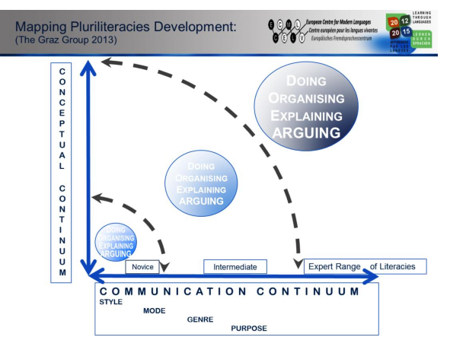
There is no doubt that we are all aware of the importance of cultivating such productive literacy through our CLIL teaching. Thus this ECML Project on CLIL and Literacy. During the first year of this ECML project, we have tried to define all the different dimensions that determine the quality of a text and bring them together into a visual model which we can use to easily see and understand how these “text properties” interplay.
What this model tries to demonstrate is that, to help learners produce a well-written text, teachers must draw their attention to two elements, or continua: the conceptual continuum regards the understanding of the information students would like to express, which interacts with the communication continuum. The communication continuum is more than just language and language accuracy but involves the choice of style (formal or informal), mode (spoken or written, visual, digital, etc.), genre (description, recount, definition, etc.) and, very importantly, the purpose for which the text is written (e.g. to explain, to formulate a hypothesis, etc.). As students progress, they should be able to produce a wider range of texts skillfully, maturing from one who can manage a “novice range of literacies” to one who masters an “expert range of literacies”. The dashed curved arrows illustrate how this progressive maturation in literacy is cumulative such that students become increasingly more effective communicators when it comes to, for example, the “doing, organizing, explaining and arguing of science”. Successful
progression in literacy means that students become increasingly more skillful in producing a range of communicative products (e.g. texts, oral presentations, visuals etc.) which reflect an awareness of the audience, context and thus purpose of their communication.

This model serves both teachers and learners in at least two ways. First, it raises awareness towards literacy by clearly identifying the components of effective communication. Secondly, the model provides both teachers and students a way to “visually map” out students’ progression in literacy: we could, so to speak, map each one of our students’ texts onto the model and thus trace their literacy development over time. Thje Graz group is now working with teachers to make the model useful by populating it with different kinds of exemplars and materials:
- Examples of tasks which foster literacy development
- Examples of students’ production as examples of what constitutes strong or weak communicative products (e.g. written texts etc.).
- Video-taped teaching sequences which illustrate how teachers work towards and scaffold successful text production.

